Michigan HOSA Graduation Cords Requirements
Below are the requirements for graduating seniors wishing to wear Official HOSA regalia at their graduation ceremony. These cords are a milestone that all seniors should strive for, a chance to show their community the organization that has brought them so much personal growth and career success.
Requirements for Graduation Cords & Stoles
-Must be a member of HOSA for 2 years minimum (current membership is required)
-Must have participated in at least 2 competition events
-Must have place in top 10 at the Regional level and competed at a State Leadership Conference
-Must have at least a 3.5 GPA average
-Must have authorization from your HOSA advisor, who has full authority to decide whether or not this is deserving of the individual under any circumstance

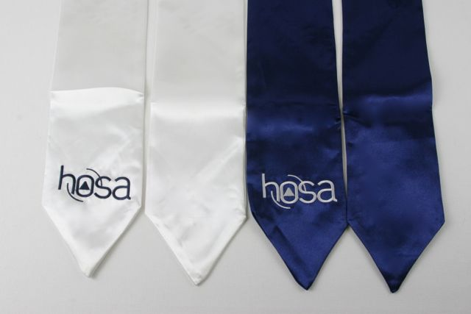
Graduation stoles and cords can be ordered online through Awards Unlimited at
https://hosastore.americommerce.com/store/Search.aspx?SearchTerms=Graduation%20Stole
https://hosastore.americommerce.com/store/Search.aspx?SearchTerms=Graduation%20Honor%20Cords%20-%20HOSA

